Research Capability Funding (RCF)
Responsive Call
Early Ideas (Type 1)
Supporting research in primary care, community care, public health & social care

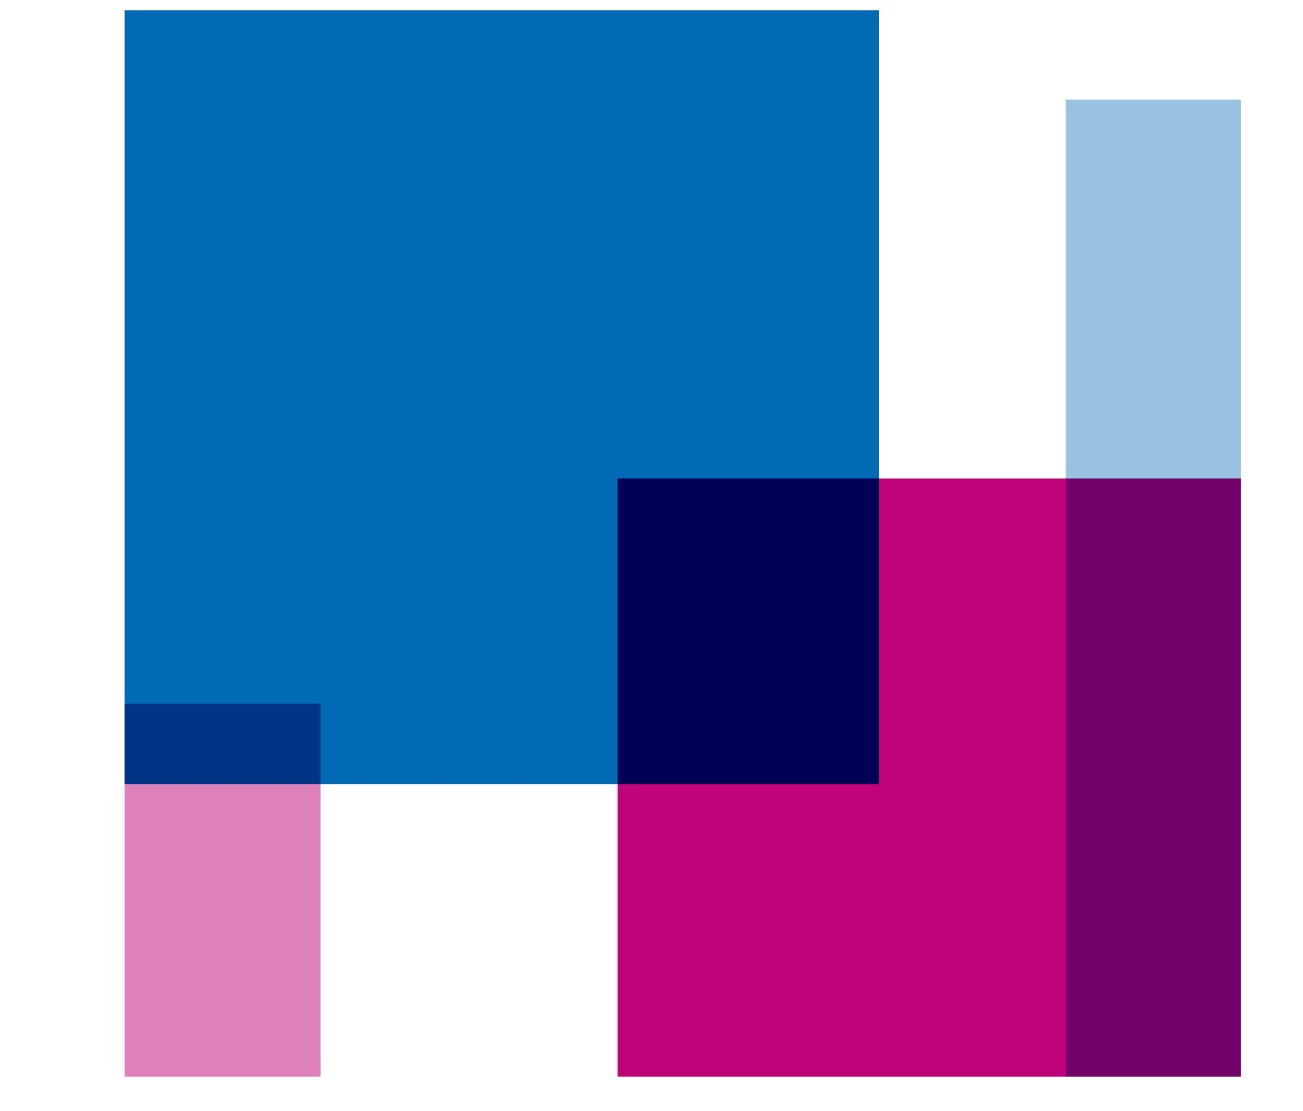



Contents
The Responsive call 3
Early Ideas (Type 1) RCF 3
Review 5
Process 5
Panel 7
Timings 7
Eligibility 7
Context of RCF 8
Constraints on award 8
Timing 8
Award amount 8
Transparency 9
Project Reporting and Performance Management 10
Sharing expertise and Collaborating 11
Deadlines 12
Contacts 12
FAQs 13

The Responsive call

There will be three Responsive call reviews per year, January, June and October. Exact dates will be advertised on the ICB website.
There are two “types” of Research Capability Funding (RCF) on offer in our Responsive call.
Early Ideas (Type 1) RCF has a set award of £3,000 intended to explore a topic area with all relevant people (stakeholders) and to co-design a specific research question. It is paramount that the population with lived experience are involved in the very start of research question development, in research design, and throughout delivery.
NIHR Grant Preparation (Type 2) RCF has an upper limit of £20,000 which can be used to develop a specific research question into a National Institute for Health and Care (NIHR) grant application. Unfortunately, this does not include Fellowship applications, however we have other RCF schemes to support this activity.
This guidance refers to Early Ideas (Type 1) RCF, there is a separate guidance document on our website for NIHR Grant Preparation (Type 2) RCF applications.
Please note that this is a competitive process with limited funds available.

Early Ideas (Type 1) RCF

The expectations on recipients of Early Ideas awards are to meet with relevant people who have relevant experience within the topic area. This would typically include academics, practitioners, service managers, Patient and Public Involvement (PPI) and colleagues involved in health and care planning.
The aim of Early Ideas RCF is to create research priorities and specific plans in collaboration with people with lived experience, as well as those involved with the planning and delivery of health and/or care services.
It is expected that the plans developed within an Early Ideas RCF award would be submitted as a Type 2 RCF application within one year. We will follow up with all recipients regularly to check in on progress and offer support.
The Early Ideas application involves a short form, with applicants asked:
- to explain the area of health they wish to research
- to justify why their chosen area is worthy of RCF investment from the ICB.
Successful applicants will be awarded a set amount of £3,000.00.
ICB Priorities
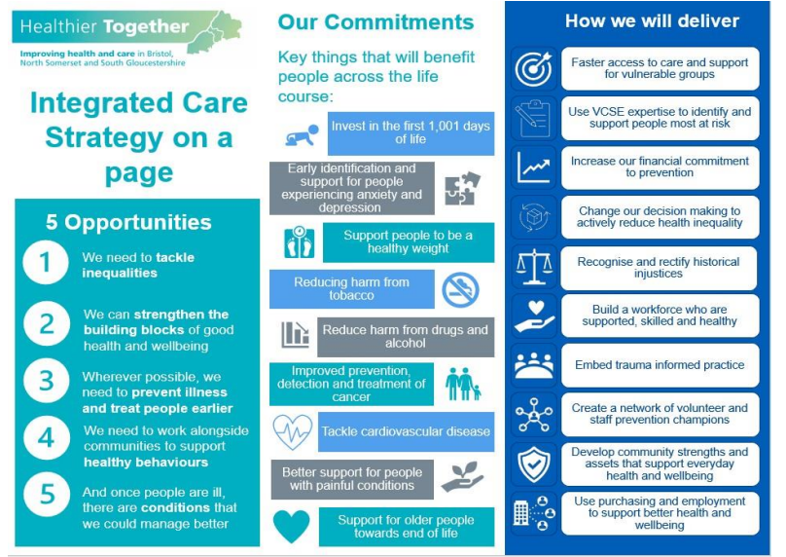

Areas of Research Interest
Areas of Research Interest (ARIs) are specific topics or issues that the government is interested in.
They are a way for government organisations to indicate that they’re keen to hear research evidence or insights related to that area.
ARIs are wide-ranging and can cover anything from economic and social policy to international relations and national security. By identifying ARIs, the civil service can ensure that research efforts are targeted where evidence is most needed to inform policy decisions and improve government performance.
ARI Database | Search, browse or analyse Areas of Research Interest (ARIs) from UK governmental bodies.
References
References can be supplied, either embedded into the answer, added as a list to the end of the application or as a separate document.

Review
Our aim is to ensure that our RCF investments compliment health and care priorities, and that the resultant NIHR submissions are strong and have a good chance of being approved for funding by the NIHR panel.

Process
Step 1 Remit Check
The ICB Research Team reviews to ensure that the topic is within the ICB’s remit and completes a search for existing literature and research funding that would make the RCF application unlikely to secure NIHR funding.
The review also confirms that the project is research. The term research means different things to different people, but for Research Capability Funding purposes, research is defined by the Department of Health and Social Care (DHSC as “The attempt to derive generalisable new knowledge by addressing clearly defined questions with systematic and rigorous methods.” We are not able to award funding for evaluations, audits or service improvement projects for existing services.
For further information please see the NIHR Glossary
Step 2 Review
Early Ideas applications are assessed on the factors below: Remit assessment, Health Inequalities and Strategic alignment.

Step 1:
Remit Assessment
Judged by trained members of ICB Research Team

Step 2:
Health Inequalities
Scored 1–6
Reviewed by trained members of the ICB Research Team.
Score of 1-3 = not fundable
Score 4-6 = proceed with review

Step 3:
Strategic Alignment
(BNSSG and National)
Scored 1–6
Judged by trained members of ICB Research Team using ICB Strategic Alignment checklist
The Strategic alignment scores are added to the total scores for ranking of fundable projects.

Scoring will be between 1 and 6, from 2 assessors per criterion.
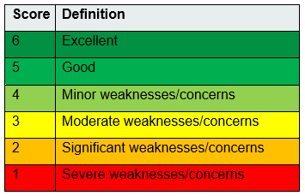
The average scores from the Health Inequalities reviews must score 4 or above for the application to be deemed fundable.
If the average score is below 4, or if the application receives a score of 1 from any reviewer, it will not be approved for funding.
The average Strategic alignment scores are added to the total scores for ranking of fundable projects.
If there is not enough budget to meet all recommended applications, they will be ranked according to their score and the ICB will award as many as is possible.
In cases where two applications are scored equally, they are separated by ranking on their individual factor scores, in the following order of priority:
1. Health Inequality score
2. Strategic Alignment score.

Panel
The panel for Early Ideas applications consists of members of the ICB’s Research Team.

Timings
We will review applications three times a year, with deadlines in January, June and October.
We will confirm outcomes as soon as possible, we aim to confirm outlines within 5 weeks. We will release all outcomes on the same day.
Awardees will be expected to join an online meeting to meet the ICB Research Team, hear about the other RCF awards, and hear what support is available for their projects.

Eligibility

Applications will be eligible if all criteria below are met:
- The lead applicant must be working for an organisation supported by the BNSSG ICB Research Team:
  - Higher Education Institution (HEI)
  - A member organisation of the BNSSG ICS
- The project must be in the area of Primary Care, Public Health, Community Healthcare, Social Care and/or Integrated Care Systems.
- The plan is to develop an idea into a Type 2 RCF application that will lead to an NIHR grant application (not a Fellowship)
- The project is appropriate for submission to the NIHR with NHS Bristol, North Somerset and South Gloucestershire ICB named as Host (contracting organisation).
Collaborative applications are encouraged, and in particular those that include university staff working in partnership with health & care colleagues.
Strong PPI is essential for all RCF supported projects, and we are looking for planned PPI activities as well as those already completed.
Applications should clearly demonstrate the need for the research, why research is the best choice (as opposed to implementation with evaluation), and clearly present the potential impact for the health & care system.
We strongly encourage applications that have the patient perspective as a clear priority.
This scheme is not intended to support the writing of NIHR Fellowship applications.

Please contact the ICB Research Team directly at bnssg.research@nhs.net if you need support for a Fellowship application.

Context of RCF

NIHR Research Capability Funding (RCF) is a research funding stream made available by the National Institute of Health and Care Research (NIHR) to help research-active NHS organisations attract, develop and retain high-quality research, clinical and support staff.
The ICB’s RCF can be used to free up time to prepare an NIHR grant application, and for pump-priming work to generate preliminary data which will support an NIHR grant application.
This scheme will not fund any activities that do not directly contribute towards an NIHR grant application.
Constraints on award

Timing
The NIHR RCF is intended to be used within the financial year in which it is issued.
Therefore, we prioritise applications for funding to support work which will start within four months of the submission deadline. The work does not need to have concluded within this same financial year.

Award amount
Early Ideas award has a set amount of £3,000. For service-led applications, the award is doubled.
The definition of a service led application is a project that has been initiated by service colleagues reaching out to academic colleagues to support work that is planned/ongoing within the health & care system. Experience shows that there is more groundwork required to get to a viable NIHR application.

BNSSG ICB is committed to increasing research activity within our populations with most need. We are piloting a scheme to help make being involved in research a positive experience for organisations involved in our Research Engagement Network (REN) and GPs at the Deep End Bristol Network. We offer additional funding to REN and GPs at the Deep End Bristol Network organisations to be used to support any improvement projects.

The funding will be paid to the organisations of existing collaborators involved in the development. If they are lead applicants and from the GPs at the Deep End Bristol Network or a REN organisation, the funding is equivalent to 48 hours of a GP/NHS band 8a. If they are collaborators on the application, the funding is equivalent to 16 hours of a GP/NHS band 8a.

As guardians of NHS funding, the panel will be judging the appropriateness of the activities listed.

Transparency
The spending of government funds must be transparent, and we promote and encourage genuine collaboration and sharing of information.
In line with this, all RCF applicants agree upon submission that if their application is awarded, their name, job title, place of work and a plain English summary of their application will be published on the BNSSG ICB website. This provides transparency on the RCF applications approved by the panel, enables other potential applicants to see what is within our remit, and gives opportunity for potential collaborators to see what work is going on locally.
We will not share the details of unsuccessful applications, but in order to help future applicants, we do publish a list of reasons for rejection provided by the panel.
If you have special circumstances which would make such a publication difficult, please indicate this clearly when submitting your application.
Please do refer to this list before considering applying for RCF.
All RCF awardees will need to report on their spend to the ICB. We will contact recipients for our annual reporting period, and at the end of their RCF duration.
The ICB reports all names and salary details of all RCF recipients to the DHSC as part of our annual finance reporting. This is completed using secure data sharing methods and is a condition of RCF awards.

Training obligations
BNSSG ICB is proud to be a leading a Research Engagement Network, which is committed to increasing the diversity of participants in research. We have learned a lot from our local community members, and as part of a national peer network led by NHS England.
One clear need is that all researchers working with communities need support to be “community ready” and for our research to make the impacts we all want to see, we need to ensure research is developed with equality, diversity and inclusion at the forefront of activities, as well as colleagues supported to understand anti-racism and cultural humility.

As such, all recipients of RCF will be expected to undertake training on these elements, or to show evidence of having been on training within the preceding 24 months.

- Trauma Informed = Trauma-informed training for those working in health and care research - Bristol Health Partners
- Cultural Competence = https://www.e-lfh.org.uk/programmes/culturalcompetence/
- Health Inequalities = https://www.england.nhs.uk/about/equality/equalityhub/
national-healthcare-inequalities-improvement-programme/contacts-andresources/
training/

Evidence of completion (or equivalent training) will be required for the final payment of the RCF award.

Project Reporting and Performance Management

All projects funded through this call will be supported and monitored by the ICB Research Team.

The ICB Research Team approach is that we are partners working to support RCF recipients to maximise their chances of success with the NIHR. Whilst we will work with you to make progress, as guardians of NHS funds the ICB retain the right to withdraw or curtail funding if progress is not satisfactory.

A member of the ICB Research Team will contact each recipient of RCF to agree a plan of progress with, if appropriate, performance indicators which will signify success for their RCF funded work.

At the end of the financial year of award being given, a report will be required of each recipient of RCF. This information will contribute to the ICB’s report to the DHSC on our RCF spend.

All RCF recipients will also be required to produce a final report at the end of their funding.

All subsequent NIHR grant applications resulting from work funded by this scheme must be submitted with NHS Bristol, North Somerset and South Gloucestershire ICB named as grant Host (contracting organisation).

Work funded by ICB RCF should start within 3 months of notification, and if the project has not started within 6 months, funding may be withdrawn.
You can contact the ICB Research Team at any time if you have any queries or would like some support with any aspect of preparing a grant application (bnssg.research@nhs.net). We encourage all RCF recipients to contact us as soon as there is a query or issue. Because we work on so many grant applications, the query or issue is often something we have dealt with several times previously.

Our main aim is to help make your NIHR application as good as it can be.

Sharing expertise and Collaborating

NHS Bristol, North Somerset and South Gloucestershire ICB is committed to the production of research relevant to health and social care.
As part of our ongoing drive to increase collaborations between researchers and healthcare professionals, a condition of acceptance of all RCF awards is that applicants will be willing to spend up to 6 hours over the lifetime of the award, or within 12 months post-completion of the award, working closely with local commissioners.
This may take the form of:
- offering general advice,
- inputting research evidence into business cases,
- delivering presentations, such as an ICB seminar,
- meeting with commissioners to discuss their interests, or
- suggesting possible evaluation approaches.

You will be contacted by the ICB Research Team if commissioners indicate that your skills and experience would be useful in this way.

Deadlines

Electronic submission of form (email attachment) to bnssg.research@nhs.net will be accepted throughout the year.
We will acknowledge receipt of your email.
See our website or the latest information on deadlines.
We plan to hold panel reviews in June, October and January each year. These timings are depending on available budget.

Contacts

We are always happy to speak through any questions applicants may have. Please email the BNSSG ICB Research Team: bnssg.research@nhs.net

FAQs

I already know what research question I want to investigate. Can I apply for an NIHR Grant Preparation (Type 2) without having received an Early Ideas (Type 1) award?
Yes: Applicants can submit a NIHR Grant Preparation submission if they have already identified a specific question to investigate. However, the panel are charged with supporting research which is co-developed with NHS and/or Local Authority colleagues and with strong PPI. Applicants who choose to opt out of the co-development period Early Ideas will have to demonstrate strong collaboration with health & care and PPI partners. The panel may recommend funding an Early Ideas award if the project is strong on other elements but is deemed in need of stronger PPI to design the RCF work.
I have developed several ideas from an Early Ideas award. Can I submit more than one Type 2 applications from a single Early Ideas award?
Yes absolutely: We hope that Early Ideas awards will identify several research questions. We will be open to receiving as many as the applicant wishes to submit. If there are a high number of ideas, it would be wise to prioritise with the collaborators as the main limiting factor will be the applicants’ time available to dedicate to writing NIHR applications. We are happy to help prioritise if you would like our input on this.
Further, there may be ideas for improvements that do not require research and could be enacted if the information was provided to the right team within the health system. The ICB Research Team are here to deliver this. Please highlight any and all learning to the ICB Research Team.
Can I defer a NIHR Grant Preparation application from an Early Ideas award?
The intention is that each recipient of an Early Ideas award will submit at least one NIHR Grant Preparation application within 12 months. However, should several potential research ideas develop from an Early Ideas award, we would have an open door policy, and welcome further NIHR Grant Preparation applications at any/all subsequent RCF calls.
What are the panel looking for in an Early Ideas application?
The panel are looking to invest in developing research in areas of importance to the healthcare system. All areas of healthcare are important to those affected by the particular condition, as a health commissioning organisation we need to be convinced that the topic area:
- is within the remit of BNSSG ICB research – primary care, community care, social care, public health, integrated care and population health management.
- is of strategic importance i.e. a published priority of Healthier Together, NHS England, one of our Locality Partnerships and/or a BNSSG Local Authority.
- has clear potential to increase health within existing budgets, and/or
- has clear potential to reduce spending within the health system without decreasing patient outcomes and/or experience.
- will not exacerbate health inequalities.
What are the panel looking for in an NIHR Grant Preparation application?
The panel are looking to invest in projects which:
- are within the remit of BNSSG ICB research – primary care, community care, social care, public health, integrated care and population health management.
- are within the remit of an NIHR funding stream and have a strong chance of securing NIHR funding:
  - appropriate Chief Investigator
  - viable project
  - proof of concept
  - will produce useful evidence for the health &/or care services.
- make a convincing case that they will be feasible
- have genuine co-development in a) planning development activities, b) identifying issues of concern, c) generating potential solutions, d) planning the research methodology, and e) planning the dissemination and implementation of the findings
- will produce results of real value to the users of evidence within the healthcare system. Factors which will be considered include:
  - the timing of the delivery of the results (will the issue still be an issue when the final report is published?)
  - balance of robust vs pragmatic approaches
  - outcomes which are meaningful to the evidence users
  - results that could lead to viable changes in the delivery of health and care services.
  - Project aligned to our ICP system priorities
Do I need to submit both an Early Ideas and an application for a NIHR Grant Preparation submission?
No. This was the case with our first two rounds of our revised RCF format (in 2019) but following feedback we amalgamated questions so that you only need to complete 1 form per submission: either an Early Ideas or NIHR Grant Preparation application form.

