BNSSG ICB Academic Career Award (ACA) Guidance

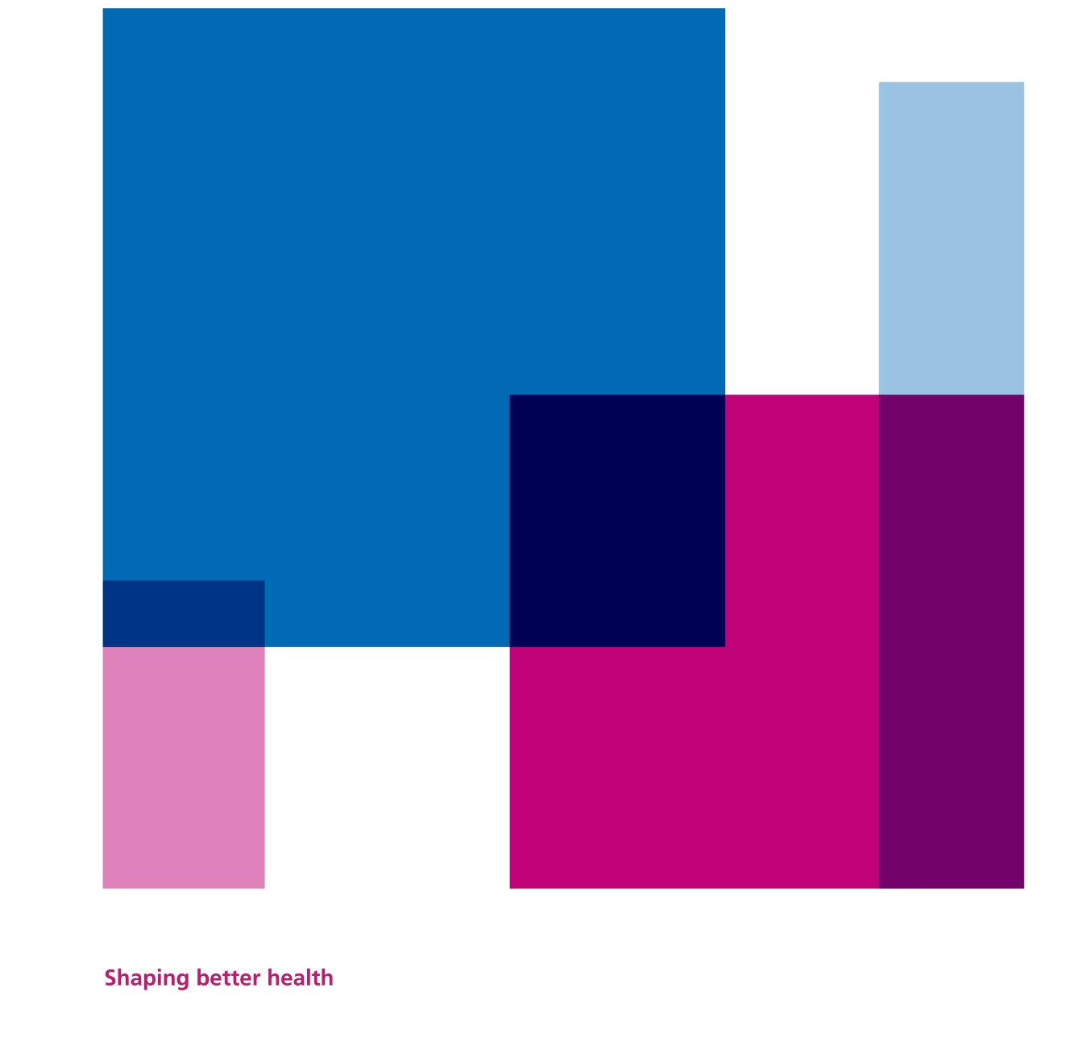

BNSSG ICB are pleased to offer our academic colleagues based in University of Bristol and UWE Bristol an opportunity to secure funding to progress their career.

Aim of this funding
To support Research Fellows, Senior Research Fellows, and Senior Lecturers who are not core-funded by their university employer.

This award will enable academics to dedicate time to activities that support their career stability e.g. applying for research grants or Advanced Fellowships.

For the ICB, this scheme will contribute to the following factors that influence our RCF spending decisions:
- The NIHR’s aims for RCF
- The NIHR’s mission statement
- Drive the pan-Bristol Knowledge Mobilisation approach
- Maintain the RCF virtuous circle

Award Terms & Duration
These Awards are intended to help reduce the pressures of short-term contracts by awarding funding equal to £60,000 over an 18-month duration.

At 18 months after the award, there will be a review meeting between the Recipient and ICB Research Team to assess how much, if any, RCF is remaining. The expectation is that the Recipient will secure other funding during the 18 months duration, and therefore may not need to draw on all their RCF Award.

If there is RCF remaining at 18 months, the duration of the RCF award will be extended in direct relation to the percentage of funding that is remaining. The table below illustrates the extension process with some examples:

Original Award | % RCF remaining at 18 months | Extension duration | Total Award duration
£60,000 over 18 months | 100% | 18 months | 36 months
£60,000 over 18 months | 75% | 13.5 months | 31.5 months
£60,000 over 18 months | 50% | 9 months | 27 months
£60,000 over 18 months | 25% | 4.5 months | 22.5 months
£60,000 over 18 months | 0% | No extension | 18 months

Application process
Awarded via a competitive process open to UWE Bristol and University of Bristol colleagues.

Following an internal selection process, UWE Bristol and University of Bristol will each be able to nominate 2 Employees to interview for the Award.

Interviews will take place at 100 Temple Street (the ICB’s offices) with a 20-minute presentation followed by interview.

The interview panel will consist of:
- ICB Senior Manager
- ICB Associate Director for Research
- Senior academic representative from UWE
- Senior academic representative from University of Bristol

Dates for the scheme
Launch: 13th October 2025
Application deadline for nominated candidates: Thursday 15th January 2026 (midnight)
Interview: Thursday 22nd January 2026
Award starts: 1st March 2026

Eligibility and Remit
As with all BNSSG ICB RCF awards, the remit for the work must be Health & Care in the community, which includes primary care, community care, public health, adult social care and/or children’s social care, and the work must support the purpose of the Healthier Together Integrated Care System:
- improve outcomes in population health and healthcare
- tackle inequalities in outcomes, experience and access
- support broader social and economic development
- enhance productivity and value for money

This funding is for academic colleagues who are a Research Fellow or Senior Research Fellow at the University of Bristol, or an individual in a senior academic/research position at UWE Bristol, who are not core funded by their University employer.

Eligibility criteria
UWE Bristol and University of Bristol are invited to submit up-to 2 applications each. Applicants must be:

- A Pathway 2 non-clinical academic or health and social care professional excluding doctors and dentists (to align with NIHR criteria*) who are a Research Fellow or Senior Research Fellow (Bristol), or an individual in a senior academic/research position (UWE Bristol), employed on either:
  - a fixed term contract, or
  - open-ended basis linked to fixed external funding
- The applicant should be working either on a full time or part time basis.
- An exemplar of good citizenship and collegiality (please note, this will require evidence of a positive contribution - the absence of negative feedback is not sufficient).
- Able to evidence excellent internationally leading research outputs that are of a standard to be submitted to future REF exercises.
- Able to evidence a sustained track record (> 3 years) in obtaining external research income either individually as CI or as a team scientist co-applicant working within successful research groups.

* with apologies to Doctors and Dentists, these funds are explicitly to create an opportunity for staff who have limited opportunities and/or representation through alternative existing schemes.

Acknowledgement
This funding scheme was the idea of Chris Salisbury, Professor of Primary Health Care at University of Bristol and a Bristol-based GP. In 2023 Chris was awarded the George Abercrombie Award by the Royal College of General Practitioners ‘for outstanding contributions to the literature of general practice’, this scheme is a fantastic contribution to our local research environment.

Chris worked with the Research Team as a previous Head of the Centre of Academic Primary Care in Bristol, and as the Chief Investigator on several large NIHR funded research projects.

Chris suggested this funding scheme as a much-needed way of supporting academic colleagues working in health & care research through offering a chance for some stability in a career often filled with precarious contracts.

We’re really pleased to be able to offer this opportunity, and thankful to Chris for what has proved to be a popular scheme and much-appreciated support for deserving colleagues.

