Integrated Care Partnership Board

Agenda Item | 8 | Meeting Date | 10.11.22

Title | Integrated Care System strategy development
Scope: System-wide or Programme? | Whole system | X | Programme area  (Please specify)
Author & role | Sebastian Habibi – Healthier Together Programme Director
Sponsor / Director | Colin Bradbury – Director of Strategy, Partnerships and Population Health, BNSSG Integrated Care Board
Presenter | Colin Bradbury/ Matt Lenny/ Sebastian Habibi
Action required: | Decision and discussion
Discussion/ decisions at previous committees | Please list below all relevant Steering Groups/Boards, along with dates and what decisions/endorsements were made)
Integrated Care Partnership Board:
21 July 2022, 15 September 2022

Purpose:
The purpose of this item is to:

- Update the Board on progress since the last meeting on 15 September
- Confirm support for the proposed approach to developing the draft interim strategy document for December:
  - Narrative framing
  - Outline document structure
  - Timeline
  - Strategic vision
- Signpost key next steps

Summary of relevant background:
- Discussions at 15 September Board meeting

On the 15 September the ICP Partnership Board received presentations and discussed key findings from the ‘discovery phase’ of work on the strategy, which demonstrates the case for change. A 1-page summary of key messages is set out at the end of this paper as Appendix 1.

- Progress since the 15 September Board meeting

- Draft success criteria for the ICS strategy were presented at the ICP Board seminar on 4 October. Board members expressed support for proposed success criteria for the development of our system strategy within a new way of working together. The proposed criteria comprise of 6Cs:
  - Clarity – a lucid, shared analysis of our key challenges and an evidence-based agreement on our priority areas
  - Candour - honest conversations about what the drivers/ root causes of our priorities are
  - Commitment – each partner signing up to do what is necessary to meaningfully address our shared key priorities
  - Collaboration – pooling our strategic resources and intelligence to create a BNSSG Strategic and Knowledge Network
  - Consistency – a recognisable thread running through all partner strategies coming from the agreed BNSSG system strategy
  - Consequential – our strategy has real, quantifiable impacts on improving lives

- Draft prioritisation principles for the ICS strategy were presented at the ICP Board seminar on 4 October. Board members expressed support for developing a prioritisation process based on the following principles and approach:
- We will use evidence (quantitative and qualitative) to identify our key opportunities for meeting our 4 objectives
- We will focus on those priorities that have a high potential to impact at a population level, combined with a susceptibility to a strategic solution.
- We will ensure a strong equality impact assessment is conducted before putting forward a suggested priority (as we do not want to widen the health inequality gap by providing interventions that only those with high levels of personal and social capital are likely to access/ benefit from)
- We will balance priorities that address the causes of premature mortality (e.g. cancer and heart disease) with those which degrade quality of life but aren’t in themselves fatal (e.g. anxiety/ depression and chronic pain)
- Agreed priorities need to be measurable in terms of delivering improved outcomes/ results
- Agreed priorities need to be costed and affordable/ resource releasing
- We will be clear about the timeline (short, medium or long term) that the delivery our priorities are likely to have an impact
- We will regularly review our priorities, reapplying the principles set out above

- The next step is to develop a prioritisation process. This process will facilitate consensus and decisions on which problems we need to focus on tackling, why and in what order. The prioritisation principles will guide the design of this process.
  - We have limited capacity to address key strategic issues at any point in time and therefore we need to be clear about how to prioritise. Any one issue we choose to address comes at the cost of the opportunity of doing something else. We therefore need to have a clear rationale, underpinned by pre-agreed principles, for prioritising the tackling of one issue above another.
  - We expect that the prioritisation process will be iterative to facilitate progress from prioritising problems into evaluating potential opportunities.
  - The December draft strategy paper will describe the prioritisation process and identify the problem, and opportunity areas that we are focussing on as emerging priorities.
  - By March we expect to have confirmed priority areas for the development of strategic solutions and any commitments on measures of success and the expected timeline for delivery.
  - The outputs from the prioritisation process will provide a clear rationale to explain what changes we will make and why and for what we are going to focus on first. For example, given the immediacy breadth and scale of workforce challenges that we face across the ICS, we may decide to prioritise collective action to improve recruitment and retention and to increase productivity.
  - For issues that do not come out immediate priorities from this process, we also need to be clear what that means. For some issues it will mean either carrying on with business as usual - taking more time to explore whether we can identify opportunities for strategic solutions - or deciding that the issue is better addressed through operational improvement. For other issues it may mean a reduction, pause or cessation of activity. This will not necessarily be because that work was not adding value, but rather because more benefit could be gained elsewhere using the resource.

- A BNSSG Strategic Network is being established to support the development, coordination, implementation and monitoring of BNSSG’s first system wide strategy. The inaugural meeting is due to be held on 8 November.
  - The purpose of the Network is to facilitate collaboration, convene strategic resources and intelligence across the ICS to focus on a shared set of goals. As a Network it will operate symbiotically to deliver value for the system and constituent parts so that it is self-perpetuating and all parties feel an ownership for it.
  - The role of the Network would be threefold:
- To shape and oversee the development, monitoring and refining of our shared strategy for BNSSG to deliver improved health outcomes for our residents. This would include a plan to use our respective strategic teams’ capacity in a coordinated way in order to ensure coherence, efficiency and de-duplication of effort.
- For its members to act as “ambassadors” for the BNSSG Strategy back into their organisation – keeping their colleagues informed and engaged in the BNSSG Strategy’s progress and also securing corporate commitment to the proposals being developed. Ambassadors would ensure that their own organisational strategy documents reflect and include our agreed System Strategy priorities and approach.
- The third dimension to this network would be the pooling of our knowledge, in order to inform our System Strategy. Again, the objective here would be to use our available intelligence resources and expertise across the whole system to greatest effect. It should be recognised that there have been a number of attempts to do something similar to this in the past. These initiatives have perhaps not been fully successful because there was an absence of an overarching agreed strategic direction to work to, coupled with a focus on quantitative/ big data, but with less attention being paid to qualitative intelligence and insights.

- Decision making and Governance. Proposals are being developed to help build consensus within the governance framework of the ICS and in recognition of the statutory role of the ICP in setting the strategy. An overview of the proposed approach is described in Figure 1.

Figure 1 – Critical path for BNSSG strategy development and approval

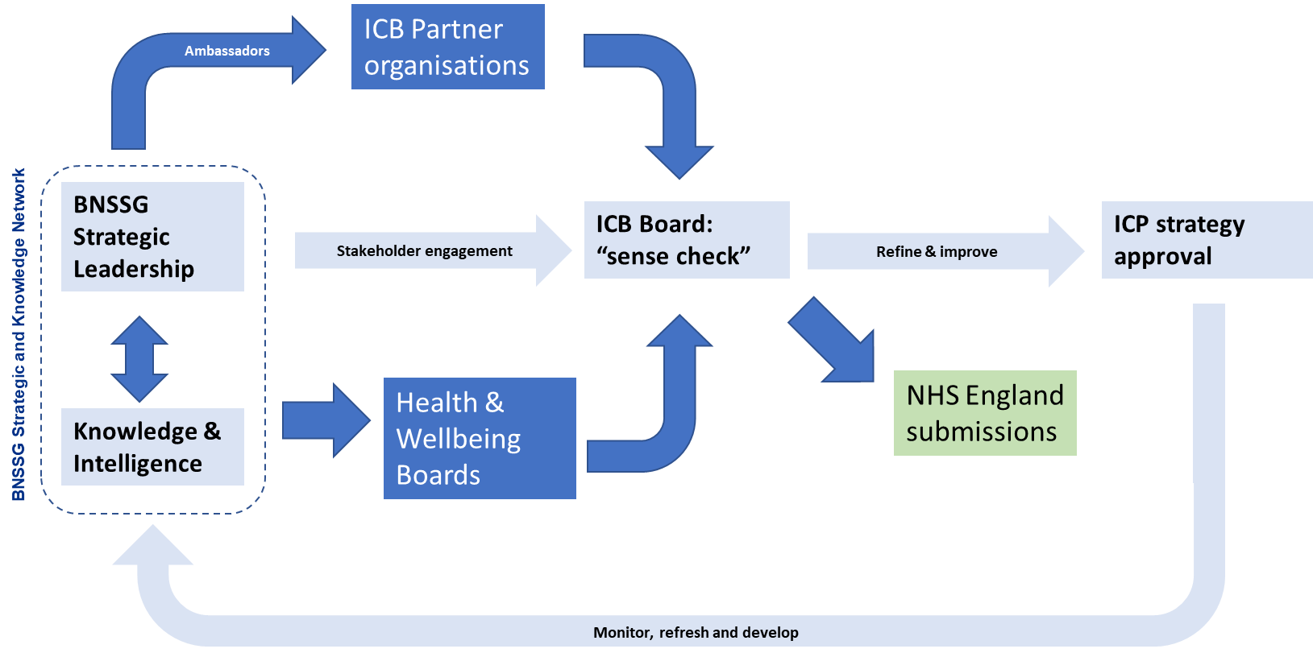

- Partnership Day, 18 October 2022

Over 200 participants from 88 different organisations across the health, local government, and the voluntary & community sectors in Bristol, North Somerset and South Gloucestershire joined the ICS Partnership Day held on 18th October 2022 in Weston-Super-Mare.

3 facilitated sessions were held focussing on:
- The opportunities and challenges for our partnership
- Working together as a partnership
- Future strategic focus areas

A draft output from the event is attached at Appendix 1.

- Overarching messages. The Executive Summary summarises the key messages under the following headings:
  - A major theme that emerged from the day was bravery
  - COVID provided us with a “common enemy” and shared focus
  - There is a need to move away from some elements of current culture – including the “blame game”
  - We are starting to see a shift from thinking about medical needs in isolation, to considering social support and wellbeing
  - Support to children and young people was one of the most discussed topics of the day
  - A key enabler and success factor will be our ability to move money and resources “upstream”

- Opportunities. Reorientating the system towards prevention was the most highlighted opportunity emerging from discussions, with a number of suggestions on how to get there:
  - Shared Health and Care workforce strategy and plans: addressing the current barriers, social care / NHS disparities, avoiding internal competition and building career pathways across the system e.g. through apprenticeships and lessons from NHS reservists during the pandemic.
  - Maximising potential of communities, community assets and the VCSE sector: needs an equal partnership and voice, utilising skills and experience, and providing wider support structures and upstream prevention within communities e.g. through support to vaccination programmes.
  - Cultural shifts: suggestions included trauma-informed, collaborative, co-production, being bold and radical, shifting the focus to wellbeing & health (including social models and social prescribing).
  - Delivery mechanisms: partnering with schools, joint funding and long-term investments (3-5 years), human-centred design and building expertise to co-design services.
  - Working together as a system: “without walls”, a holistic approach, shared risk, outcomes and data.
  - Children and young people: including support for mental health and childhood obesity.

- Challenges. Some of the main challenges identified included:
  - Workforce: retention, attraction, parity, competition and poaching.
  - Prioritisation: our focus is always on the current burning platforms and firefighting. More austerity to come will only make this worse and leads to “organisational insularity”.
  - Funding: needs to be long-term and sustainable. We might not see the returns immediately but need to invest to save and be brave with funding collaborations. Current short-term focus will be tough to shift.
  - “More of the same”: trying to do too much, not making difficult decisions, being too process and target driven and failing to deliver on our strategies and plans.
  - Sharing power and inclusivity: truly giving everyone an “equal seat at the table” will require power shifts, listening, building trust and shifting resource where it is needed. Today is a good start but it needs to be followed up.

The next step is to write out to all the people that attended to the event with a letter of thanks, setting out next steps in the strategy development process and a link to the microsite where the presentations and output slides from the event will be published.

Decisions required and recommendations:
- Narrative framing

Our engagement with stakeholders during September and October has highlighted the importance of how we construct the narrative frame of the strategy. A clear and coherent narrative frame for the ICS should help to:
- Reinforce the 4 ICS aims as the purpose that is to be served by the strategy
- Highlight the problems that we need to solve
- Provide a logical structure for setting goals and prioritising where we focus our collective resources on developing solutions

Feedback from the Partnership Day discussions indicates that we are making good progress in building shared understanding of where we are now and the problems that we need to solve.

“The partnership day led to increased confidence in participants’ knowledge and understanding of the challenges facing the BNSSG partnership, with 90% of survey respondents feeling “very” or “moderately” confident after the event.” (Partnership Day post event survey)

Feedback from the Partnership Day highlighted support for focussing solutions development at key stages of the life course (e.g. Children and Young People; Older Age and Frailty). This feedback resonates with what we have heard in our meetings with Health and Wellbeing Boards and our engagement with Locality Partnerships in identifying emerging priorities for the system strategy.

Having regard to this feedback we are proposing a narrative frame for the strategy that is structured around (see Figure 2):
- Purpose of serving the 4 ICS aims
- A life course structure for developing and delivering solutions
- Consideration of short, medium and longer term impact

Figure 2 – Narrative Framing

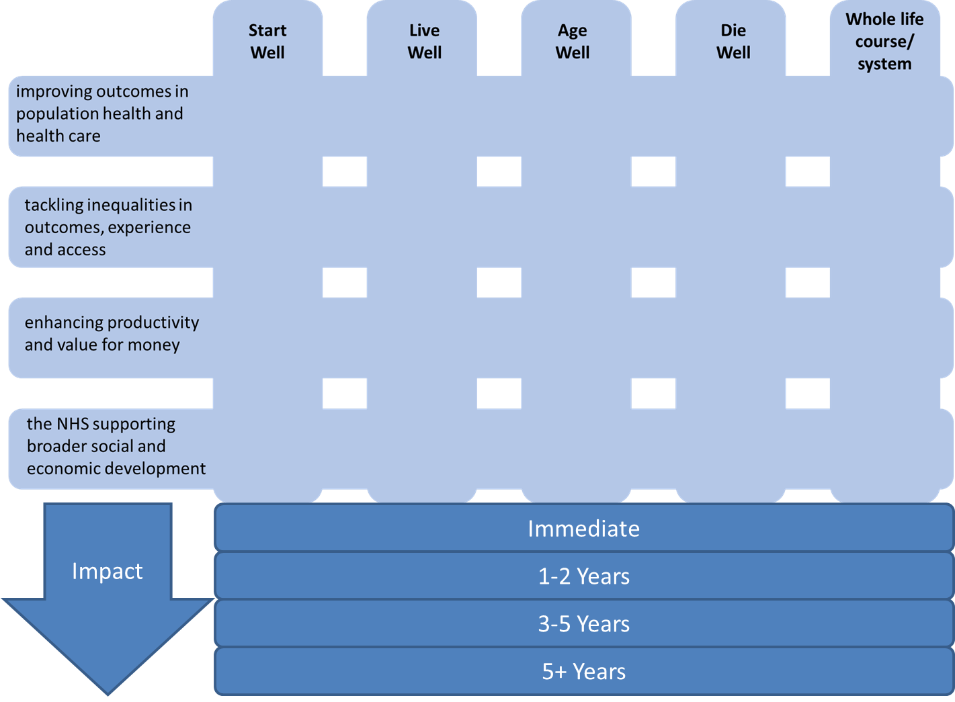

- Outline structure of December interim strategy document

We are proposing an outline structure for the December interim strategy document as set out in Figure 3. This will take the form of a work-in-progress draft strategy paper that is taken to the ICP Partnership Board at a public meeting in December. The Board will be asked to confirm support for the direction of travel and the next steps in the process to develop V1.0 of the ICS Strategy for approval by end of March.

Figure 3 – Outline structure of December interim strategy document
- Introduction  - Foreword: purpose of this document and its intended audience  - Statement of support – ICP Chairs/Health and Wellbeing Board Chairs and ICB Partner Chairs and Chief Executives  - Executive Summary  - Case For Change – where are we now?  - Introduction  - Our Aims  - Outcomes  - Population Health Outcomes  - Healthcare Outcomes  - Inequalities  - Outcomes  - Experience  - Access  - Productivity and Value  - Productivity  - Allocative value  - Broader Development  - Social  - Economic  - Environmental  - Our Capacity  - Workforce  - Finance  - Feedback from Have Your Say public engagement exercise  - Where do we want to be?  - Introduction  - Our ICS strategic vision  - Our Partnership Principles  - Inputs to date  - Staff  - Partners  - Data and Evidence  - National and International Best Practice  - Learning from the pandemic | - Prioritisation process  - Longlist  - Prioritisation principles and methodology  - Emerging Priorities  - Start Well  - Live Well  - Age Well  - Die Well  - Lifespan/whole system  - Locality priorities  - NHS Long Term Plan  - Strategic Enablers  - Workforce  - Risk Management  - Finance  - Digital  - Estates  - Communications  - Sector  - Operational  - Sustainability/Green plan  - How will we work together differently?  - BNSSG 2.0: Success criteria/6Cs  - How our ICS will work  - How we will organise ourselves to deliver our strategy  - ICS Strategic Network  - Strategy Group  - Knowledge Group  - Health and Wellbeing Board  - Locality Delivery Model  - Outcomes Approach to Monitoring Delivery  - System Agreements  - Annual Review and Refresh  - Next steps  - Ongoing stakeholder engagement plan  - Governance  - Timeline

As the December document will be an interim strategy document it will reflect the work-in-progress at that point in time. Some sections will be more developed than others. In particular, the ‘emerging priorities’ will be subject to further development and decisions through a prioritisation process that will run into the new year.

- Timeline for December interim strategy document

Key milestones in the timeline:
- ICB Board review – 1 December
- Strategic Network review – 6 December
- ICP Partnership Board meeting in public to confirm support – 16 December

- Strategic Vision

The current ICS vision, values and goals were endorsed by the previous Partnership Board as part of the process for developing the ICS Memorandum of Understanding (MOU) and system development plan. A summary is set out at the end of this Document as Appendix 2. This provides a starting point for the December interim strategy document and for further development of the ICS strategy going forwards.

- Next steps

Key next steps in the strategy development process in the new year:
- Further development and iteration of prioritisation process (Dec-Feb)
- Governance process for approval of V1.0 of the ICS Strategy (Feb-March)

- Decision

The Board is asked to confirm support for the proposed approach to developing the December interim strategy document and to note next steps for further development of V1.0 of the ICS Strategy to end of March.

Appendix 1
Key messages on the case for change, presented to the Board on 15/09/22
On the 15 September the ICP Partnership Board received presentations and discussed key findings from the ‘discovery phase’ of work on the strategy. This discussion highlighted key issues driving the case for change, including:

- BNSSG population health strategic needs assessment findings on:
  - Most impactful conditions at different stages of the life course, notably: anxiety and depression (all ages); painful conditions (working age adults); Diabetes (older adults); and, cardiovascular disease (the biggest cause of premature mortality)
  - Systematic inequalities in population health outcomes, associated with ethnicity, deprivation and learning disabilities & autism
  - Impact of health inequalities in driving up the lifetime cost of care for the BNSSG population by c£100m per year
  - Impact of healthy and unhealthy ageing driving significant variation in the distribution of multi-morbid conditions
  - Impact of multi-morbid conditions as a key driver of acute hospital bed day usage, e.g.: c66% of annual bed days due to falls being attributable to c3% of the BNSSG population

- Impact of resource constraints and reduced productivity driving gaps in capacity to meet demand, which will widen if current trends continue:
  - Reductions in productivity post-pandemic, as growth in expenditure and numbers of staff in post have reached historical highs, whilst activity remains significantly below pre-pandemic levels
  - Unsustainable system finances:
    - c£76m underlying deficit in the BNSSG NHS
    - Growth in social care expenditure running lower than growth in demand and inflation and threat of cuts to local authority budgets going forward
  - 16% average vacancy rate across the BNSSG ICS, rising to >20% in some areas of community services and mental health
  - Increasing patient complexity/level of need and the impact of delays in transfers of care (and associated decomposition), is driving unsustainable growth in length of stay/bed day usage, both in hospital and community settings, e.g.:
    - Increases in hospital length of stay from 2019/20 to 2021/22 were equivalent to c33,000 beds days (c100 beds)
    - Growth in patients with No Criteria to Reside from c367 per day in April 2021 to c575 per day in April 2022
  - Ongoing increases in BNSSG wating lists and in +52week waiting times for diagnostics and surgery
  - National outlier on key system performance indicators, including ambulance handover delays, access to specialist mental health support and cancer treatment.

Appendix 2 – Current ICS Vision
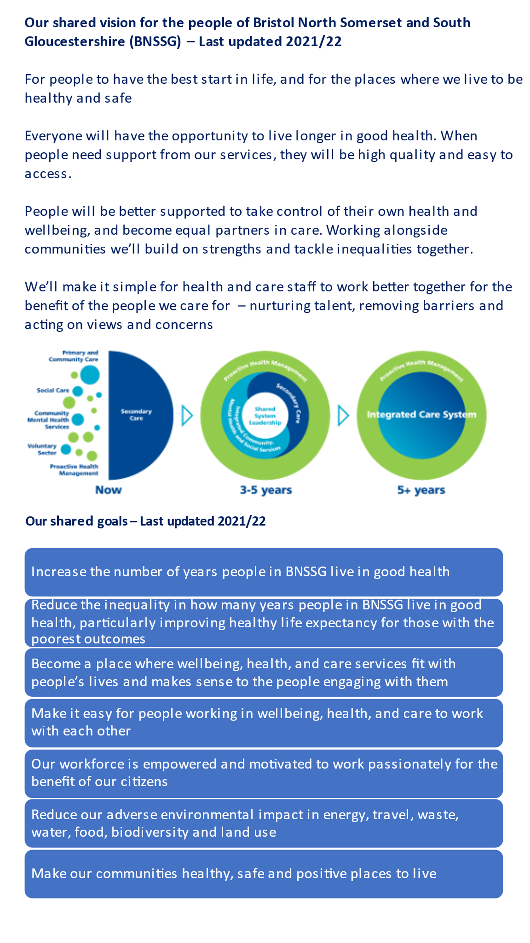

Some opportunities may have a high potential to impact at a population level, but we might not have the technology, staff or resources to realise them. Other high impact opportunities will not need a strategic solution and therefore are not within the remit of this work. For example, we may have strong evidence that increasing health checks for a certain group will improve outcomes for that population, so we would need to link into operational colleagues in such cases, rather than leading a strategic change.
In many cases, the same intervention may have an impact across the short, medium and long term. For example, smoking cessation or diabetes reversal will have an immediate benefit, which will continue to accrue/ develop over time.

