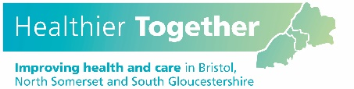
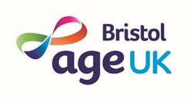
Community Boost Grant
Application Form

Use this form to tell us about you and the project you would like us to fund. Please read the guidance notes before completing. If you are applying for funding for more than one activity please complete separate forms for each.
About you
Name of organisation or group:
Are you a: ☐ Registered Charity ☐ Community organisation
☐ Unincorporated group ☐ Other - please state:

Please tell us in one sentence what your group does:

Main contact for this application
Title: Forenames (in full):
Surname:
Phone number:
Email (if available):
How would you prefer us to contact you? Phone ☐ Email ☐
How much funding are you requesting for your project? (Maximum £2,000)
Please complete the cost breakdown table on page 4

About your project

Please write 150-200 words per questions 1-4

- What do you want to do with the funding and how will it address health inequalities in your neighbourhood or community?

We will be looking at whether your project is likely to improve the health and wellbeing of people experiencing or at risk of preventative ill health.

- Have you spoken to people who would be interested in participating in your activity?

If some of the proposed participants are submitting the application, please make this clear. If not, we are looking for evidence that you have gathered support from the people you seek to benefit and involved them in the planning.

- How will you make sure your activity is as accessible as possible?

We will be looking for a commitment to including people from diverse backgrounds, particularly those who face barriers to other health and leisure activities or services

- How do you plan to continue the project beyond the Community Boost Grant?

We will be looking at whether you have given due consideration to being able to continue the activity beyond the period supported by the funding

- Who do you think will benefit from the project? Please give an estimated number of people

We will be looking at the value and cost effectiveness of your activity

6. Please provide details of any particular groups of people you are working with or hope to reach through your activity

Activity details

When do you intend to start the activity?

Where will the activity take place?

Have you received any other grant funding for this activity?

Yes ☐ No ☐

If yes, please provide details:

Cost breakdown

Please complete the below table listing each item or service required for the activity, continuing on a separate sheet if necessary. For further information on goods and services eligible for the Community Boost Grant, please see the guidance notes.

Item | Cost
Total cost

Thank you for completing this form. Please return it to rossettib@ageukbristol.org.uk. You can also post the form to Bianca Rossetti, Community Boost Grant Programme, c/o Age UK Bristol, Canningford House, 38 Victoria Street, Bristol BS1 6BY

Deadline for applications: midday on Friday 16th September 2022

