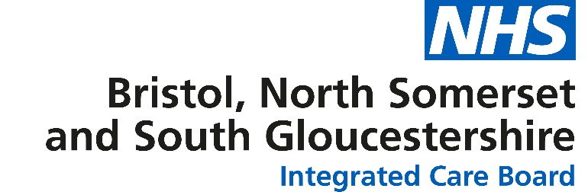

Gifts, Hospitality and Sponsorship Declaration form

Recipient Name
Position within, or relationship with, the ICB (or other organisation):
Date of Offer
Date of Receipt (If applicable)
Details of Gift / Hospitality/Sponsorship
Estimated Value (£)
Name of person/company making the offer and nature of business
Details of any previous offers or acceptance by this person / company
Name of Officer reviewing and approving the declaration made and date
Was the Gift / Hospitality/Sponsorship Accepted or Declined?
Reason for accepting
or declining
Other Comments

The ICB is required to take steps to manage conflicts of interest that may arise; we collect this information to ensure that we are able to comply with the statutory guidance on this subject. The information collected in this form will be held securely and used for the purposes of identifying and managing conflicts of interest. Personal information will be managed in line with the General Data Protection Regulation and Data Protection Act 2018. Details of gifts, hospitality and sponsorship are published online and available on our website. Information may be disclosed to third parties in accordance with the Freedom of Information Act 2000 and published in registers that the ICB holds.
I confirm that the information provided above is complete and correct. I acknowledge that any changes in these declarations must be notified to the ICB as soon as practicable as and no later than 28 days after the interest arises. I am aware that if I do not make full, accurate and timely declarations then civil, criminal, professional regulatory or internal disciplinary action may result.
I do / do not (cross out as applicable) give my consent for this information to be published on registers that the ICB holds. If consent is NOT given, please give reasons below:
Employee Signature:
Employee Print name:
Date:
Line Manager Signature:
Line Manager Print name:
Date:

Please return to The Corporate Team, bnssg.corporate@nhs.net

